Oumou Balde

BIS 31

Pr Tanweer

Project question

December 20, 2017

Project question 3 Two part form Salary

3)

Create a two-part form that calculates and displays the amount of an employee’s , salary based on the number of hours worked and rate of pay that you input. Use an HTML document named paycheck.html as a web form with 2 text boxes-one for the amount of hours worked and one for the rate of pay. Use a PHP document name paycheck.php as the form handler.

Answer:

code

Paycheck.html

<html>

<head>

<title>Enter Paycheck Data</title>

</head>

<body>

<h2 style = "text-align:center"> Enter Paycheck Data </h2>

<form name="paycheck" action="Paycheck.php" method="post">

<p>Hours Worked: <input type="text" name="hours" /></p>

<p>Hourly Wage: $<input type="text" name="wage" /></p>

<p> <input type="reset" value="Clear Form" /> &nbsp;

&nbsp; <input type="Submit" name="Submit" value="Send Form" /></p>

</form>

</body>

</html>

Paycheck.php

<!DOCTYPE html PUBLIC "-//W3C//DTD XHTML 1.0 Strict//EN"

"http://www.w3.org/TR/xhtml1/DTD/xhtml1-strict.dtd">

<html xmlns="http://www.w3.org/1999/xhtml">

<head>

<title>Process Paycheck Data</title>

<meta http-equiv="content-type" content="text/html; charset=iso-8859-1" />

</head>

<body>

<h2 style = "text-align:center">Process Paycheck Data</h2>

<?php

$errors = 0;

if (is_numeric($_POST['hours'])) {

if (($_POST['hours']) > 0) {

$hours = round($_POST['hours'],2);

if ($hours > 40) {

$regular_hours = 40;

$overtime_hours = $hours-40;

}

else {

$regular_hours = $hours;

$overtime_hours = 0;

}

}

else {

++$errors;

echo "<p>Error: 'Hours Worked' must be greater than 0</p>\n";

}

}

else {

++$errors;

echo "<p>Error: 'Hours Worked' must be a numeric value</p>\n";

}

if (is_numeric($_POST['wage'])) {

if (($_POST['wage']) > 0) {

$wage = round($_POST['wage'],2);

}

else {

++$errors;

echo "<p>Error: 'Hourly Wage' must be greater than 0</p>\n";

}

}

else {

++$errors;

echo "<p>Error: 'Hourly Wage' must be a numeric value</p>\n";

}

if ($errors==0) {

echo "<p>$regular_hours hours @ \$$wage/hr = \$" . ($regular_hours*$wage) . "<br />\n";

echo "$overtime_hours hours @ \$" . ($wage * 1.5) . "/hr = \$" . ($overtime_hours*$wage*1.5) . "<br />\n";

echo "Total for $hours hours is \$" . (($regular_hours*$wage) + ($overtime_hours*$wage*1.5)) . "</p>\n";

}

?>

<p><a href="Paycheck.html">Calculate another paycheck</a></p>

</body>

</html>

After we run the Paycheck.html in the server, we have the form below

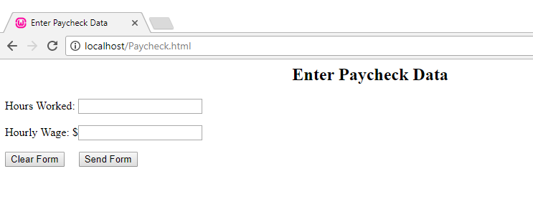

We enter some data

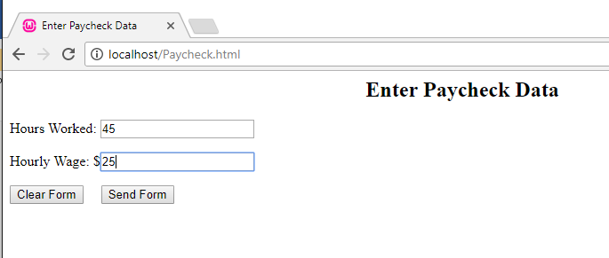

The result is below

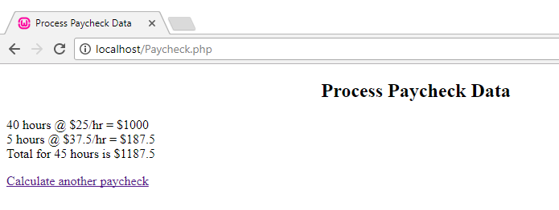

If we enter 0 for hours worked

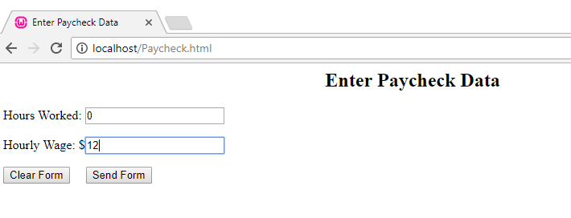

We have the errors below

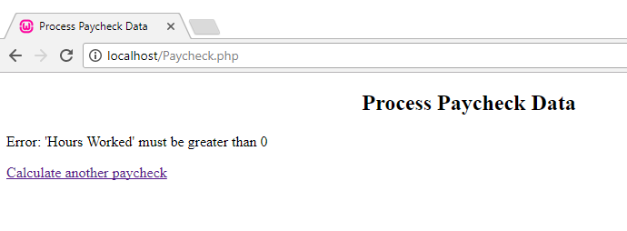

If don’t enter anything and we click Send Form

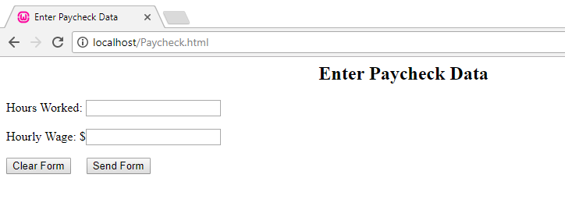

We will have this errors

